Social Group Camps

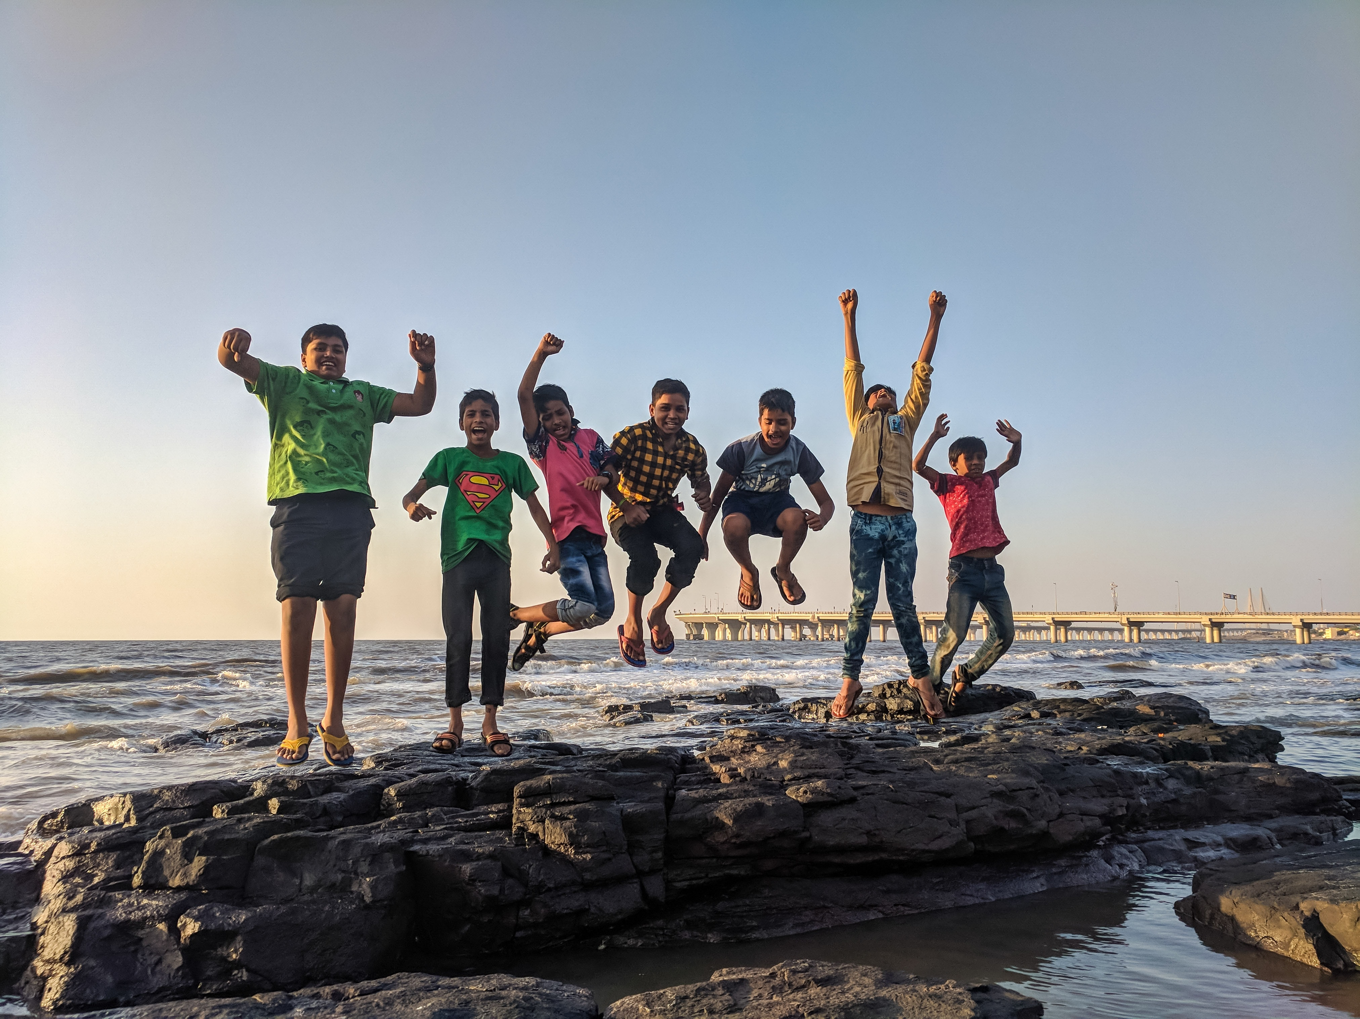
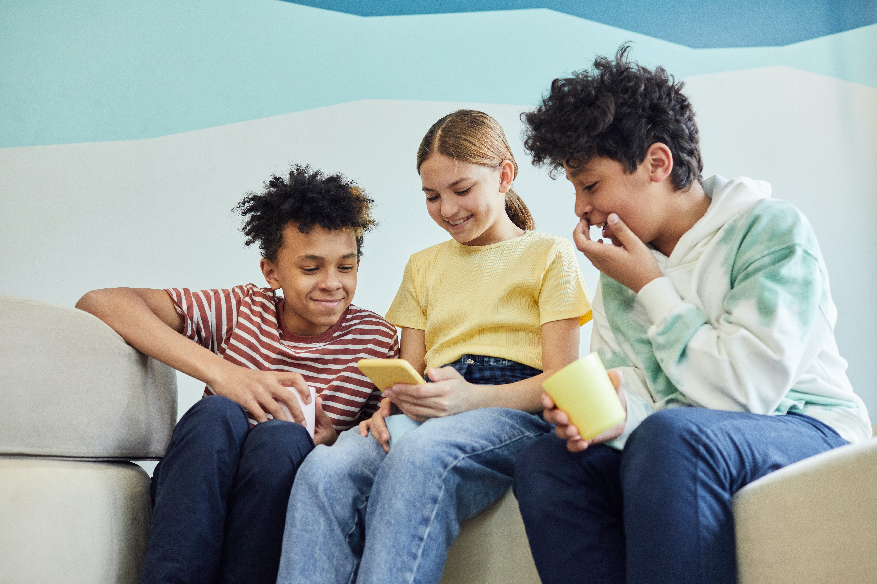

We will be offering two social group camps in July. Learners will work on enhancing their peer interactions in a safe and interactive setting.

Groups will target social thinking skills, social problem solving, perspective taking, friendship skills, etc.

July 18-22 – Ages 8-10

July 25-29 – Ages 12-14

Time: 9:30-12
Location: Semiahmoo Speech Services
207-15230 56th Ave, Surrey, BC
Fees: $625
Instructor: SLP Gabrielle Johnston

If you have any questions please feel free to reach out to our admin team at admin@semispeech.com

